Kevin Bastoul

ID: 4394748478

2/10/17

Programming Homework #2 Report

EE/CSCI 451

How to run my program:

To run the program, you navigate to the folder with all the files and type “make” from the command line. This should make all the programs. You can then run each program simply by typing its executable name:

P1 -> p1

P2 -> p2

P3 -> p3a, p3b

For p1 and p2 you need to enter a value for the number of threads. The command needs to be of the form: “p1 4”

Problems:

1. Parallel Matrix Multiplication

*** The results shown here were produced on my local machine with n=1024 for the matrix dimensions. ***

|  |  |
| --- | --- |
| Number of Threads | Execution time (ns) |
| 1 | 13297505000 |
| 4 | 6436080000 |
| 16 | 6403057000 |
| 64 | 5541422000 |
| 256 | 5068085000 |

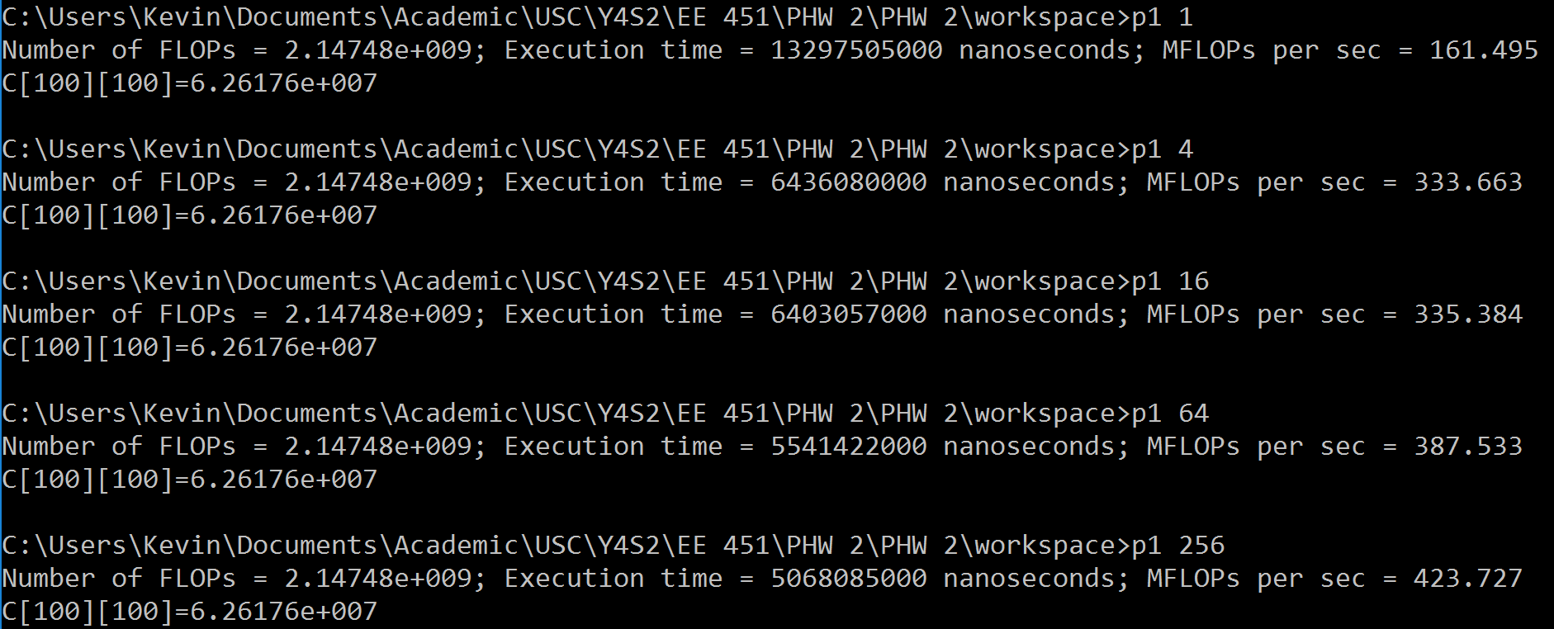

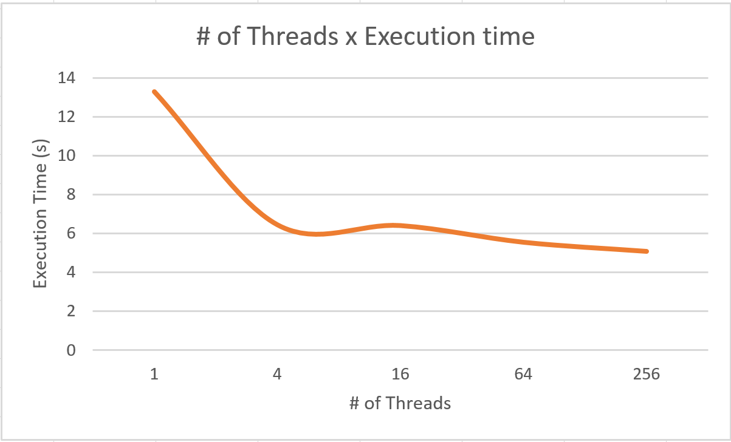

1. Parallel K-Means

|  |  |
| --- | --- |
| Number of Threads | Execution time (ns) |
| 1 | 1278006000 |
| 4 | 1877337000 |
| 8 | 1861825000 |

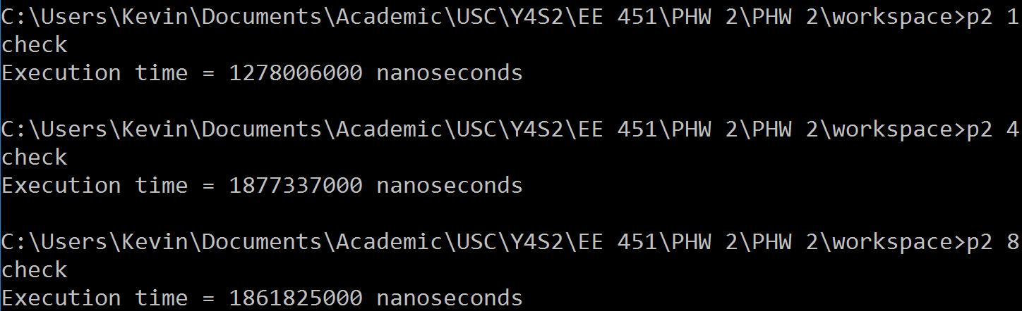

It seems that there’s a slight slowdown from a serial to multithreaded implementation, and then negligible speedup from 4 threads to 8 threads. This could be due to the overhead of setting variables for each thread which increases with the number of threads.

1. Producer-Consumer
   1. Part a (not the full output)
      1. 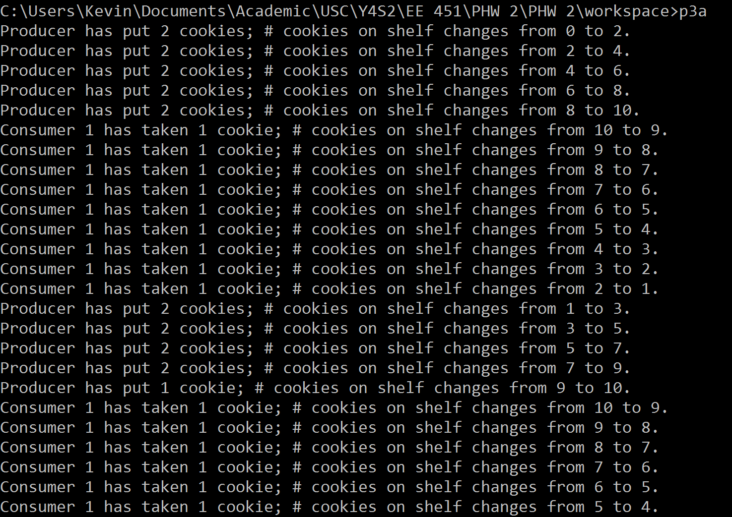
   2. Part b (not the full output)
      1. 